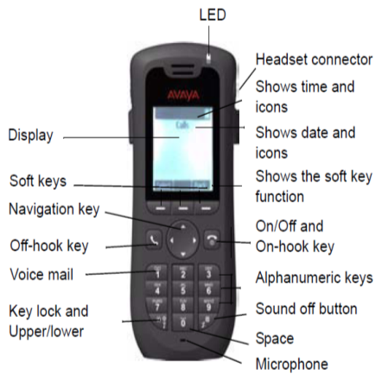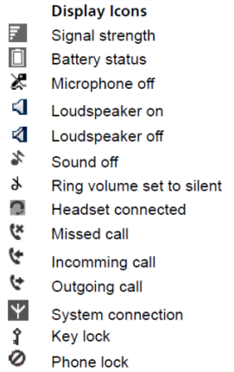

**DECT Phone Tips and Tricks**

**Features of Your New DECT Phone**

Your new DECT phone is a vast improvement on the previous model with some great new features including:

* **Improved battery life:** 80 hours of talk time & 200 hours of standby
* **Conferencing:** need just a couple of folks? Conference them in!
* **Loudspeaker:** one touch loudspeaker
* **Ringtones:** set a different ring tone for internal vs external calls
* **Talk & Charge:** headset connects on the side!

**BASIC FUNCTIONS**

**Switch on or off:** Press and hold the **On-hook** key 

**VOICEMAIL**

Voicemail commands all stay the same:

* Dial 5858 to access your mailbox (0191 297 5858 from outside)
* Enter extension followed by #
* Enter pin followed by #
* Press 2 to hear your messages
* 0 to play message
* *3 to delete message

**Make a call:** Dial the number and press the **Off-hook** key  OR

Press the Off-hook key and enter the number

**Answer/End a Call:** When the ring signal sounds, press the **Off-hook** key to answer. To end the call, press the **On-hook** key.

**Turn Loudspeaker Function On/Off:** During a call, press the left Soft key to turn the loudspeaker function on/off.

**Change the volume during a call**

Use the Navigation key to adjust the volume.

**Silence Phone**

In stand-by mode a long press on the **Sound off **key changes between audio signals on/off. The **Sound off** icon indicates a completely silenced telephone.

A short press on the **Sound off** key silences the ring signal.

**Lock/Unlock the Keypad during a call**

To prevent accidentally pressing keys, the keys can be locked during a call. This can be useful when a headset is used and the handset is attached to a pocket or belt.  
**Lock Keypad:** Hold down * and then press Lock key.

**Unlock Keypad:** Press * and then Yes.

**MORE ADVANCED**

**Conferencing Numbers In**

When in a call, press ‘R’ (right soft key) to get a new line. Your original call will go on hold. Dial the second number, wait for an answer and then press ‘R’ again – all parties will now be in a conference.

If you in fact want to transfer the call at the point you can hang up and the other two parties will stay connected.

**Divert Calls to an Alternate Extension or External Number**

1. Dial *22 (dial tone will follow)
2. Enter YOUR extension number (will go to dial tone)
3. Enter number you wish to divert (remember the 9 if external!)
4. Wait for 4 beeps

**Stop Divert: D**ial #22 and then enter your extension